Problem No:
Problem Statement:

Codes:

#include <bits/stdc++.h>

using namespace std;
int main()
{
map<int, string> ordered_map;
ordered_map[1] = "One";
ordered_map[3] = "Three";
ordered_map[2] = "Two";
ordered_map.insert({5, "Five"});
ordered_map.insert({4, "Four"});
ordered_map.insert({6, "Six"});
cout << "Size of ordered_map: " << ordered_map.size() << endl;
cout << "Is ordered_map empty? ";
if (ordered_map.empty())
{
cout << "Yes";
}
else
{
cout << "No";
}
cout << endl;

cout << "Ordered Map Elements: ";
for (auto p : ordered_map)
{
cout << "[" << p.first << " -> " << p.second << "] ";
}
cout << endl;
cout << "Value of key 3: " << ordered_map[3] << endl;

if (ordered_map.contains(2))
{
cout << "Key 2 exists, erasing it." << endl;
ordered_map.erase(2);
}

cout << "Lower bound of 3: " << ordered_map.lower_bound(3)->first << endl;
cout << "Upper bound of 3: " << ordered_map.upper_bound(3)->first << endl;

unordered_map<int, string> unordered_map;
unordered_map[1] = "One";
unordered_map[3] = "Three";
unordered_map[2] = "Two";

unordered_map.insert({5, "Five"});
unordered_map.insert({4, "Four"});
unordered_map.insert({6, "Six"});

cout << "Unordered Map Elements: ";

for (auto p : unordered_map)
{
cout << "[" << p.first << " -> " << p.second << "] ";
}
cout << endl;

cout << "Does key 5 exist? " << (unordered_map.contains(5) ? "Yes" : "No") << endl;
unordered_map.erase(1);

cout << "After erasing key 1, size: " << unordered_map.size() << endl;

return 0;
}

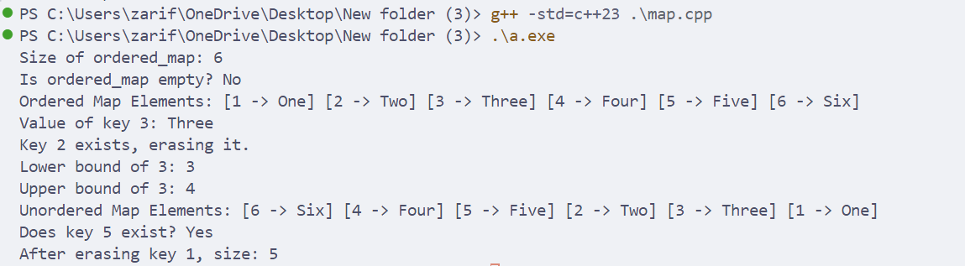

Problem No:
Problem Statement:

Codes:

#include <bits/stdc++.h>

using namespace std;

int main()
{
set<int> _set = {10, 20, 30, 40, 50};
cout << "Size: " << _set.size() << endl;
cout << "Max Size: " << _set.max_size() << endl;
cout << "Is empty? " << (_set.empty() ? "Yes" : "No") << endl;

_set.insert(25);
_set.insert(60);
_set.insert(10);

_set.erase(20);

if (_set.contains(30))
{
_set.erase(30);
};

cout << "Does 40 exist? ";
if (_set.contains(40))
{
cout << "Yes";
}
else
{
cout << "No";
}
cout << endl;

cout << "Set elements: ";
for (auto p : _set)
cout << p << " ";
cout << endl;

cout << "Lower bound of 25: " << *_set.lower_bound(25) << endl;
cout << "Upper bound of 25: " << *_set.upper_bound(25) << endl;
set<int> a = {1, 2, 3};
set<int> b = {4, 5, 6};
a.swap(b);

cout << "After Swap - a: ";
for (auto p : a)
cout << p << " ";
cout << endl;

cout << "After Swap - b: ";
for (auto p : b)
cout << p << " ";
cout << endl;
return 0;
}

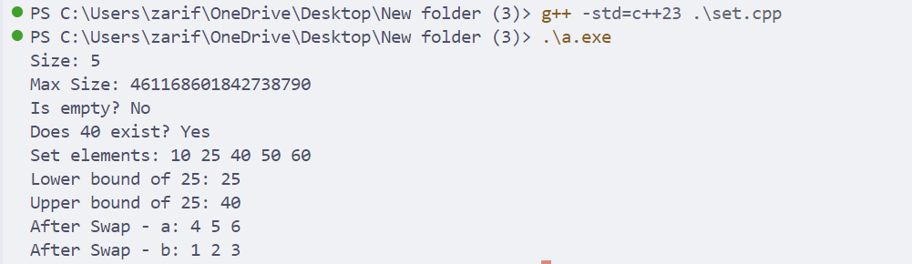

Problem No:

Problem Statement:

Codes:

#include <bits/stdc++.h>

using namespace std;
int main()
{
vector<int> _vector = {10, 20, 30, 40, 50, 60};
cout << "Size: " << _vector.size() << endl;
cout << "Capacity: " << _vector.capacity() << endl;
cout << "Max Size: " << _vector.max_size() << endl;

_vector.push_back(60);
_vector.insert(_vector.begin() + 2, 25);

_vector.pop_back();
_vector.erase(_vector.begin() + 1);

cout << "First Element: " << _vector.front() << endl;
cout << "Last Element: " << _vector.back() << endl;
cout << "Element at index 1: " << _vector.at(1) << endl;

_vector.resize(10, -1);
_vector.reserve(50);

cout << "Vector elements: ";
for (auto p : _vector)
cout << p << " ";
cout << endl;

cout << "Using Iterators: ";
for (auto it = _vector.begin(); it != _vector.end(); ++it)
cout << *it << " ";

cout << endl;
cout << "Is empty? " << (_vector.empty() ? "Yes" : "No") << endl;
vector<int> a = {1, 2, 3};
vector<int> b = {4, 5, 6};
a.swap(b);

cout << "After Swap - a: ";
for (int x : a)
cout << x << " ";
cout << endl;
cout << "After Swap - b: ";
for (int x : b)
cout << x << " ";
cout << endl;
return 0;
}

Output:
